Name : Gayatri Pansare
Roll no:73
Exam : End Sem pratical

Tableu DashBoard
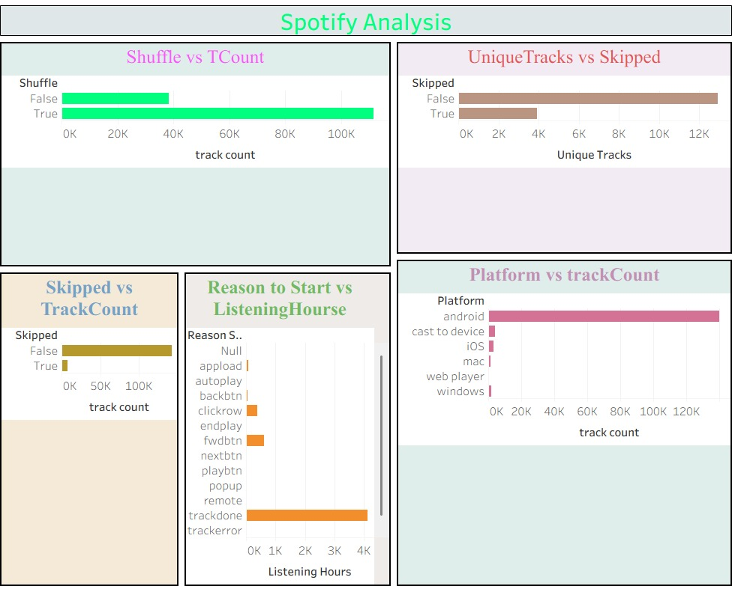

Dashboard of Power BI
